Josep Serneguet
Analyst-Researcher
From the LITICA Library of ICA
http://www.piedrasdeica.net
Email: jserneguet@gmail.com
BPublication allows (Spanish)
Barcelona, 18 de Diciembre de 2015

Introduction
This ambitious research project tries to analyze along a singular route of something more than 40,000 km, of no less than nine rings, which will show us, as are aligned a good number of centers of ancestral cultures and cosmopolitan cities of Our times, which presumably have nothing of chance, rather seem to obey A cosmic Plan, capable of generating Communication vortexes Between the cosmos and the planet.
Possibly this is the way in which it is transmitted, a programmed evolution between the creators-Gods and Humans, I would almost say, From the beginning Of the life of the Great Cosmic Biology Lab, which is Earth.
We will also analyze the crosses and telluric points where three or more
Rings, which in turn form triangles or polygons, possibly centers of contact between humans and creators, where unknown secret codes are activated, present only in the upper dimensional planes, as I documented in Decrypted from Nazca, 1st and 2nd part, where argument, that Ocucaje is the biggest vortex of the planet and the board where the creators "write", messages destined for humanity of all time.
It is unquestionable the importance, at the level of exact sciences, the fact that these rings exist, aligning telluric points, such as temples, pyramids, ancestral cities or natural-looking masked spots, but What Analyzed with constructive mentality, it turns out to be rather, "artificial", let's not forget that the raw material of the concrete of the old ones, are "modifications" of the petrology of the zone.
In general, the antiquity of each and every one of these centers is lost in the night of the Times, and only the grandeur of the scarce ruins visible, thanks to its vestiges of the use of the technique of the Concrete of the old, they alert us that their inhabitants were beings with aThe Knowledges Very superiorIt is to those of our humanity. .
As the theme is extensive and laborious We will make a brief summary of the familiar part of the centers Telluric for those who passN Rings To delve into Themes of Unpublished or less known natures By readers interested in the subject.
The ambitions of this research, VBeyond the argument, as we will try to locate Missing continents, I don't I'm refiLaughing alone, to the "acquaintances", like Atlantis, Lemuria or Mu, we will seek New Continents, BasÁndonos in the ICA Stones of continents, since they have emerged in the third millennium, new continents, different from the ones known of the Museum of Ica, besides "to replicate", the already known ones, but with Changes of a certain Mattercia In their squares, that we ABClean New doors of interpretation, Possibly from the beginning.
We will not lose sight of the seabed, in Looking for those continents, Entering new postulates On the Hollow Earth, based on quantum physics.
TAlso See Although without qualification, the great cities of our humanity, That are part of the rings, which are probably a key to that Its location There's nothing casual about it, Well As I think, the planet-Laboratory, Earth, is created to be "manipulated" by our Creators Through fixed points of The planetary rings, What Move Not only the ancestral areas, they also do it with The important cities of our humanity.
Maybe that's why they line up telluric points of all time in the Rings Of This mode, the "modifications" are global In the whole planet.
ForBableMind existAnd A Common denominator, Between Cultures and The Temples Old, and this is no other than The Constructive technique, As I have documented in previous articles, The The way to build is the same, although the raw material is different, they are generally Rocks The Quarries of the area, Always Of A High quartz content.
I don't have the MEnor Doubt Of What In The Crystal Structures Is Save Keys Identical common, in all telluric points, which in turn are related to the Cosmos and are activated, when knowledge-hungry researchers view the Centers. Besides, it is very curious, that we are always the same, and we are not many. Is it that our Attitude is appropriate to receive the information?, or ratherIt A "duty" Engraved on the consciousness of the human, during his transit, by the Other Side of the veil! I think We won't have the answer In this life, as long as we're human.
The Large Center Telluric contents Of all the Rings They tend to have difficult access, In fact, they have Remained "Hidden" for thousands of years, And Good part, Is Are descubLaughing In recent years, From the beginning of the Third millennium. ¡ A brilliantly Plan Cósmico!
No I've got the Slightest doubt that EL World has been globalized By Humanities from other Planets of the Cosmos, even in different Eras, As we Indicate, andL Large NAZCA board or ICA stonesAlthough I feel that Your Main charactersBe more moderate than in the Previous articles of research.
ESpero that What the GuíAs Help me, Like so far, IsThe Ambitiouss And importantIt Travels By The Planet, in Search for our Past This, and possibly Future.

First ring

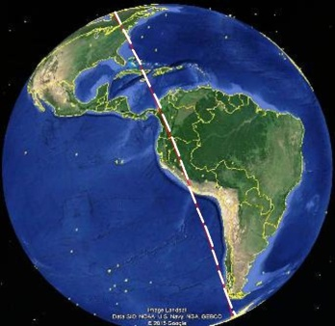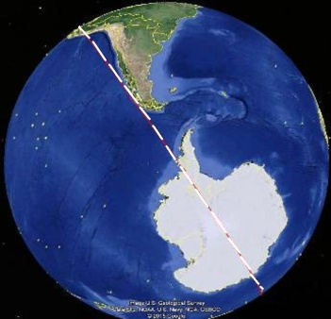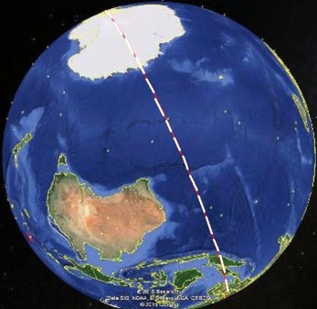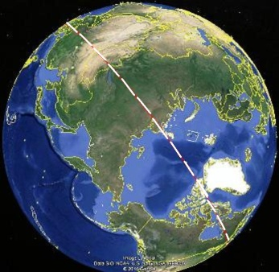

The route starts at the axis Of Candlestick of Paracas That does not carry directly to the NAZCA Plate, Leaving to your left, a Chile, Argentina And Land of Fire, Until As inr By the center of the Antarctica And Delve into Full Ocean Indian to Malaysia and The antipodes of the chandelier, the Golfo de Tailandia!
In Cambodia Visited The Temples of Angkor, We entered China, Up to the explanaDa Pyramids, We By the Gobi Desert and lake Goodál, in Siberia, until Recove in The Arctic Portal and Canada.
The first ring also goes through Megá-Police Like Washington, New York, The countries as Florida, Cuba y Jamaica, Entering the Caribbean Sea Until Colombia and Ecuador, For EndsR your Travel Where it began, on the very axis of the Paracas Candlestick, After a tour By the surface of the Earth and Seas of the planet, In a ring over 40,000 miles. The.
Whoever believes that it is casual or pure coincidence, that they make it look, ESTAmos versus A great Cosmic Plan, Completely Active and In usThe For the control and evolution of humanity of all time, in Its development process Of Great Cosmic Biology Laboratory ofL Universe.
Comenzamos The tour, this time The Points Telluric DetectedS, which will surely be More. But with which we will analyze Enoughs to see that 're Before A masterful orGood Biological Perfectly studied and planned by The Creators of life, That after multiple tests of eons of years, they have achieved their masterpiece, AndThe Ser Humano!, dual and with the creator's "Spark" in his Inside, so that through A series of limited lives And Evolutionary Generate A Way of return to our orígenes.

1.1.- CANDELABRO DE PARACAS (13°47'38.84"S, 76°18'31.23"O)
Ring Origin: 0 km

Eatcemos By the general data, based on the Wiquipedia:
The candlestick of ParacasIt's a geoglífo Famous, located on the north coast of the Paracas Peninsula, Province of Pisco, within the Department of Ica.
The chandelier measures 180 m long and is The CalculatedN A 2500 Years of seniority, sOr meaning is still a Mystery. Wiquipedia; this is the official version.
My version "Free" of So enigmatic Figure, Input, Their orientation is notcia The figures of NazcaOr There is the slightest Link As, “GuíA or signal”, from Landings of extraterrestrial ships, as I read in some books.
ESTA is one of the smoke curtainsMore UsualIt's just They sell us, to Entertain,
No pensArOr IndaEven In our origins, in order to have us in a Via Dead to prevent us from advancing our self-evolution.
But ¿A where it points The Chandelier?, Come and see!
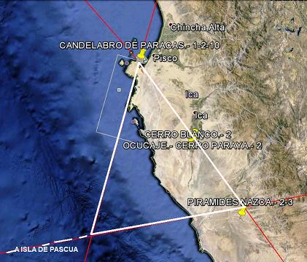
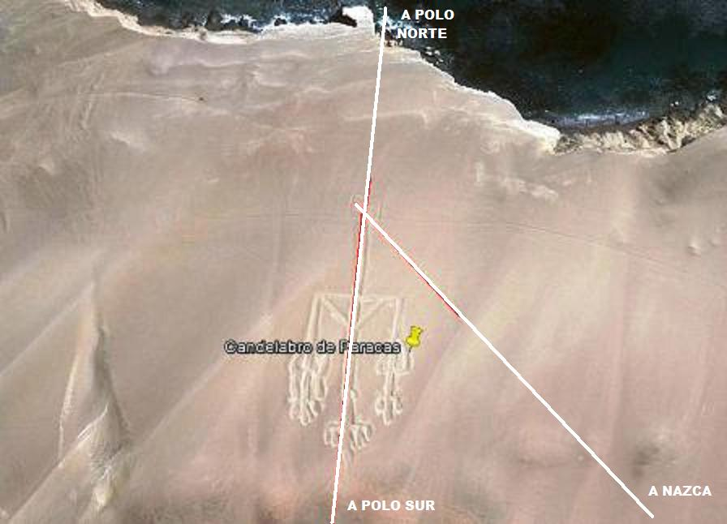
Esta pregunta me ha intrigado durante muchos años, de hecho, la curiosidad me llegó, dirección y recorrido seguía la alineación del eje del Candelabro, en sentido Sur-Oeste.
Was Stupefied After checking The importance of telluric points that I found during andL Travel Never inAginé they were alignedas perfectAmene, so many cultures that, in truth, we do not know its history, but it turns out that also they align cities of our present day, with an indisputable protagonism, political and economic, of our society.
.AYes Started a STravel of 40,075 km per All The surface of the planet, with Start and endTo In the Chandelier of Paracas, the alignment of the first ring.
Later See, What More rings Pass, To the point of What The first three, Form The Triangle Telluric More Powerful dThe planet, by which Vortex moves Incredible Let's not lose sight of that, Ocucaje, is within the Triangle and is the cradle of the Ica stones, a key point, just like the Great NAZCA Board, Points where the "tokens" of the Great Cosmic game move, Let's say that the first one is "mobile" and the second "fixed", Without No Doubt, it is the most magical area of the whole planet.
I have No doubt about QHad, In this Portal, "Update" the pCosmic Rogramación Of the evolution of life, through Biological adjustments, That are activated in the DNA of all forms of life of the planet, we are the work of an intelligent program of the creators.
The alignment is parallel to the NAZCA plate and the Patagonian Ice Field, to be introduced in Antarctica, second season of our journey

1.2.- ANTÁRTIDA (89°26'35.27"S, 140°51'25.15"E)
Distance From1.1: 8.530 km; A Origin: 8.530 km.

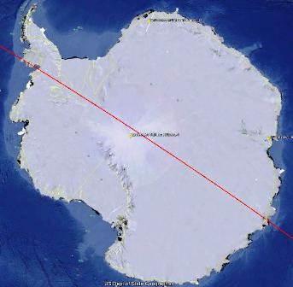
The extension of the candlestick shaft, heading south, leads us directThe To Antarctica, near the International Polar Year.
A curiosity Recent It The discovery of Pyramids on this continent of permanent ice, of course, Is DescoNoce, who built them.
As Wiquipedia, No Exists Any kind of humanity native to Antarctica, Although this Discovery It has ignited a spark, based on the Ica stones of continents, which perhaps Nos AportAría Light on Our Origins and history.
Also foundó The largest crater on the planet, After Drain a lake 3 km. deep Under the Ice, at sea.
Although this continent has always been surrounded by fabulous legends, and may questionRse Recent discoveries, The fact Become part of the First Ring is an ARgumento sufficiently solid To Believe That Antarctica Was Inhabited millions of years ago, cHen its climate was warmer and its conditions of Life more Favorable.
Personally, I think this continent of ice, Us Hide MMuch more secrets and Mysteries of which Us Imagine, especially if We consider the information that it transmits to us The Lithic Library of Ica.
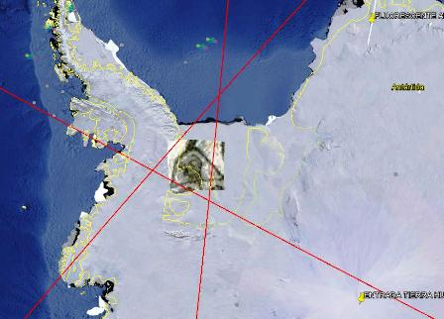
Interestingly, the series of continents, also have been Replicated In recent yearsA Possible hypothesis, to keep in mind in the not too distant future Is, that the poles and telluric points as important as that the vortexes of the Candlestick of Paracas and its antipodes, The temples of Angkor, In Cambodia, really Are "fixed" points of the Anillo Planetary, for hundreds of Millions of years, to keep Anchored These centers telluric to Any Variation of continents or level of oceans, to To alter all the life forms of the Planet, with the correspondingnTeeth extinctions and changes in biology and species, Following A Scheduled Evolution Cosmic.
The enclosed photo information is a breakthrough in future research.
At the moment, And Only in order to open new doors of research, Attached the Triangle-Vortex That form The Rings 1, 5 and 7, With the image of The Humanity What, Maybe Could Inhabit the Antarctica, but this is a very advanced conclusion, which lacks the basis of confirmation, but the intuition tells me to keep it in mind, and I do.
En the lower right side of the image Is The alleged entry a The Hollow Earth, from which Surely We'll talk later, which is curiously fashionable, again.
For all the subjects exposed, Leave the Open by a The opinion of Other Researchers.

Following the route to Indonesia, in the middle of the Indian Ocean and at an average depth of 3,500 m., we found some strange polygonal shapes Of all the Seabed, which is not is in the Evaluate, For the time being, but we leave evidence OfL its existence. During the tour, we left to the right of alignment, Australia, until we landed in Malaysia, although before we do a small scale in Java.

1.3.- Mountain Meadows Pyramid (6°59'35.77"S, 107 ° 3 ' 22.92 "and)
Distance From 1.2: 9.300 km; to Origin: 17.830 km
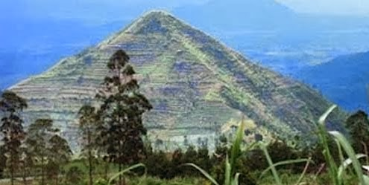
Mount Padang It's a Gravesiteo Site, Located In Karyamukti, Cianjur, On the island of JavaIn Indonesia.
ItTo Megalithic Monument Is the greatest of all the South East Asia, se cOnsidera that Mount Padang was built In four different times.
are inbicación is in a half HillyVery Rugged and inaccessible. The complexity Of Center It Enlarged And Covers the surface, Of a hill bordered by Rows of large andesites In a rectangular.
The site is surrounded by Large Valleys And Local residents, ConsideredN Sacred.
Of the investigations carried out in the area, it was concluded that, No magma intrusion. TAlso was conducted a study of the subsoil of Mount Padang, with methodology Geophysics, Appliances Geo-electric, geo-radar and of Magnetic detection, reaching the Conclusion of the Mount Padang, it's a hill, “artificial”, Made by man.
By the documented information of this Point Telluricncestral and based on its construction bases, large ashlars of andesites, plus geotechnical reports, we can Consider Monte Padang, a center made with Ancient concrete technology.

Following the lineup, we entered Malaysia, Where we find cities of great relevance in our days, as SingapuR O Kuala Lumpur, with its international business centers.

1.4.- TEMPLOS DE ANGKOR (13°26'12.92"N; 103°52'38.02"E)
Distancia desde 1.3: 2.115 km; A origen: 19.945 km
Angkor is a region of Cambodia, With The most important capitals of the Khmer Empire .
EL Temple of Angkor What, dedicated to the Hindu god, Vishnú, it was never abandoned, lor cared for centuries, Buddhist monks

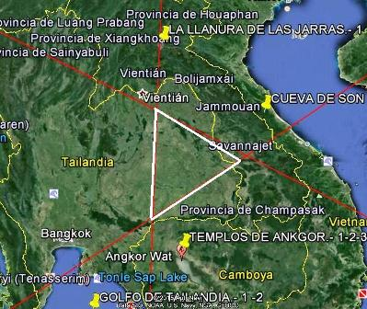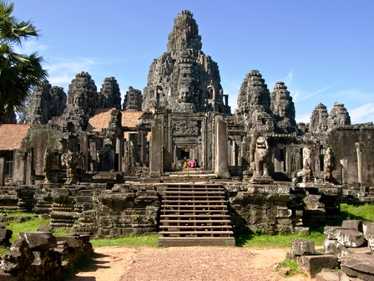
I
The ancient Temples of Cambodia, are built representing the constellation of Draco, are their exact replica, star-to-star, with extraordinary precision.
Our humanity, with all its current technology, would not know how to reproduce These temples, curiosamente, The Constelación of Draco, Not recorded in NazcaAs My research in the Article, is ofNAZCA encoded, I didn't know how to locate such an important constellation On the board, So I did say, What Their humanities They represented it in the antipodes of Nazca, In Cambodia, representing its constellation in the form of temples.
In fact, both telluric centers would be on a planetary scale, not to say Of the Universe, As eL Yin - The of our own existence and duality.
These postulates force me to ask a question,There Any particular reason?
The intuition tells me that, YesAndStoy convinced that Exist Hidden keys, engraved on our own genetics, which gradually They go unveiling, as we "activate" DNA molecules, to synchronize our "Awakening" and Ascension.
Definitely, The constellation of Draco's Of The most enigmatic, Of Great Cosmic Plan, Perhaps for your Biological and genetic contribution to our humanity. DAnd done, there's a lot of legend, On the AnunakiHalf Dragón, Half HHuman Maybe, this is the Reason by which Are Himand well represented in The Stones of Ica.
Much of it wasEfore of information, On thes Theorys Of the Conspiracy consider, What Reptilians beings They are members of the Global elite of the planet.
The impressive Construction of the temples of Angkor, with ancient concrete technology Plus the triangle-vortex forming rings 1.2 and 3, I am inclined to classify the area of Cambodia, as the second most important telluric triangle on the planet.

1.5.- LLANURA DE LAS JARRAS (19°26'0.86"N, 103° 9'8.14"E)
Distancia desde 1.4: 660 km; A origen: 20.605 km.
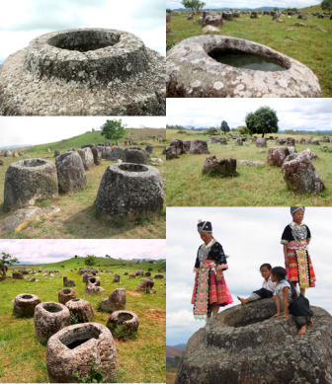
The Plain of Jars It's a historical site group-Cultural in Laos. This is an area containing thousands of jars, Scattered on the ground, On the Plain of Xieng KhouangTo Northern Laos, in the Cordillera Annamita, principal Mountain chain Of Indochina.
Local legends affirm that a race of giants inhabited The area.
LAs jars are made of sedimentary rock, And in Lesser extent, GraniteHis Angular or rounded and some have discs that could be their lids; OnSan from 1 to 6 tonnes and measure from 1 to 3 meters high.
The Jars are still Linearly The layout of paths, this detail I recordó, The Road of the Tired stones Of Sillustani, in Peru, I understand that these jugs, too, stopped on the night of the Times, perhaps at the same time as the stones of Sillustani.

GRAN BUDA LESHAN (29°32'42.43"N, 103°46'35.04"E)
Distancia desde 1.5: 1.130 km; A origen: 21.735 km.
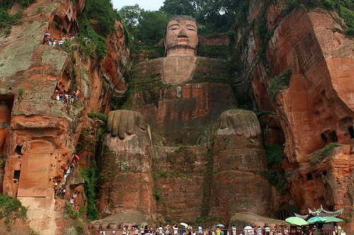
The Great Buddha of Leshan It A statue carved in stone, Highest in the world.
It is carved on a cliff inThree The rivers Min Jiang, Dadu And QingyiIn The Sur of the province Of Sichuan. (China)
The sculpture is in front of the Monte Emei and the River water runs down Buddha's feet.
In 1996The Unesco Included the Great Buddha of Leshan And The panoramic landscape of the mountain Emei, As World Heritage Site.
The Statue Has a AlturTo 71 m. and Represents, A Buda Maitreya, With MaWe're resting on our knees.
LShoulders measure 28 m. Wide and the Finger Small of the foots, Is wide enough, How to sitIs A person.
A local saying says: The mountain is Buddha, And Buddha is the mountain. The origin of this phrase is, by the fact that the mountain in which the Great Buddha is located (seen from the river) has a silhouette reminiscent of a lying Buddha.

1.7.- GRUTAS MAIJISHAN (34°23'25.88"N, 106° 6'51.00"E)
Distancia desde 1.6: 590 km; A origen: 22.325 km

A few miles south of the Silk Road in Gansu province, you will find a Great China's past artistic treasure-Las Grutas Maijishan, With their 194 caves dug into the hillside of a rock wall and adorned with More than 1.000 m2., from Murals, And 7,200 sculptures of Buddha.

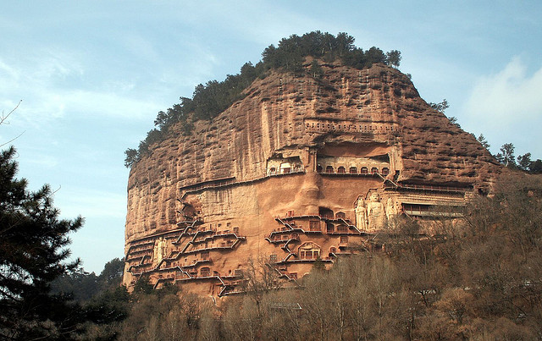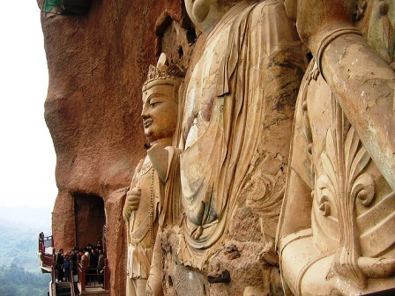

Itta Dizzy Spellsa Architecture, Built based on Cuts Vertical in the Rock, which the official science considered was made, Allegedly, between (384-417 dC), when Buddhism came a China ofsde India. It is said that its construction is Extended During More than 12 dynasties.
Through the centuries, the Isitas and maintenance, was An attraction for the monks and artists who traveled along the Silk Road, some of whom opted for Stay and continue to create works In The Caves of Maijishan, ofrecGoing Your Creativity and Talent in the construction and decoration of So Impressive caves.
As is common in these ancestral points, The "official" science forgets the enormous degree of difficulty in making such complex works, in times when the people had many problems to survive and the life expectancy was in the environment of 30 years.
The story Official Seems Do not give any Importance to these Vicissitudes and find, logical AND “realizable”, works as huge as this, In any distant epoch, Whether it was the work of the religious faith or imposition of their kings or leaders.
seem not to give importance to that, The Pueblo, I had to work hard to live, died young In wars of their leaders or kings, The by epidemics y Simple diseases, And they were also LTo eighth part Current Demographics!
PUEs Well, it turns out that As we are told, The village, tenThey had Time, Knowledge and Media, as to undertake Works of the magnitude of Maijishan.
It is clear that power takes us for fools! Thiss Works of art Hasn The seal of the concrete technology of the ancients, And that only humanities much more advanced than ours, as we see in all the telluric points that we are going through, was able to attack this type of constructions, that not only fulfill an artistic function, they are also like anchors that the creators place in Our planet to "move" the rings, depending on the degree of evolution that, its cosmic clock, tells it to start, to "modify" the Life of the planet-laboratory-Earth.

Relatively close to the caves of Maijishan, is the esplanade of the Pyramids of XI'AN, which we will analyze below

1.8.- PIRÁMIDES DE XI’AN (34°21'43.45"N, 108°38'30.52"E)
Distance from 1.7: 10 km; A Origin: 22.335 km

This complex esplanade of over 6000 Has, in the center is the main pyramid, located at the end of the Second World War, being forgotten until Early in the year 2000, when the Chinese Government recognized that there were more than 400 pyramids in the Shanxi region, north of Xi´an.
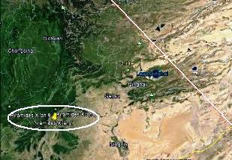
The main discovery Workers, by digging a well of more than 4m deep and discovering a series of terracotta figures With appearance Of Warriors of ancient China.
This terracotta army is formed by a multitude of warriors, chariots and Horses in the form of neatly crafted figures, who dug up the legend of the Chinese emperor, Qin Shi Huang.
The Warriors are located under a huge pyramid, with hundreds of galleries at great depth, are supposed to be missing many remains to be discovered, as the Own Tomb of the Emperor.

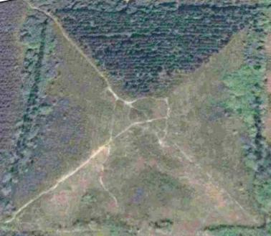
It is suspicious that the Chinese government remains silent on the emergence of 16 new unpublished pyramids, built near Xi'an, one of the pyramids measures 350 m. Base and its size is much greater than the Great Pyramid of Keops.

Personally I find Pretty Amazings, Certain legends about The Pyramids and The Warriors of Xi'an, when I see their pictures, give me the feeling of What, “Live, "for there are no two equals And I can't help it, it reminds me of the Chapter 18 of GenesisWhen Lot moved away from Sodom And Gomorrah with his family and his wife, He turned to look, becameéndose In A Statue of Salt, as he had Predicted a Lot.
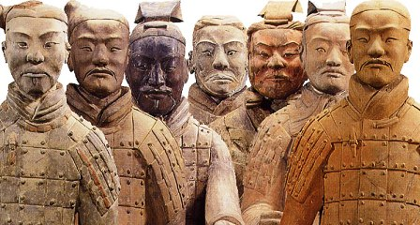
Well, surely it will be a vagary, but this biblical passage does not stop Associate, como Such a fact, which could have happened with the Guerreros de Xi’an, Based on the Technology that dominated our ancestors, What For unknown reasons, the creators became "Mud”, a whole army. Surely it may seem incredible and amazing, but in view of all the facts that we discover, Personally I think very possible this Postulated, much more than the "official", of making a hundred or thousands of statues, "different", for, Bury them, "and with an extreme fragility. I'm sorry, I don't strain.

Continuing our journey, we enter the Gobi desert, in Siberia, until we reach Lake Baikal, nearby, are the megaliths of GORNAYA SHORIA.

1.9.- LAGO BAIKAL.- 1 (52° 7'43.29"N, 105°46'14.38"E)
Distance from 1.8: 1.905 km.; A Origin: 24.240 km.

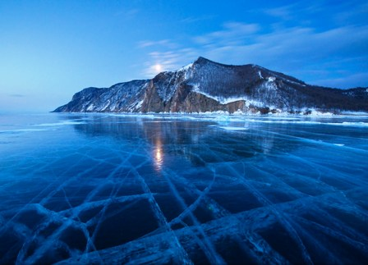
BAIKAL, is a Lake Of tectonic origin, in the southern region of Siberia, Russia, near the city of Irkutsk. Its name derives from the Tartar Bai-Fun, "Lago Rico". is also known as The “Blue Eye of Siberia” The “The Pearl of Asia”.
It is one of the lakes with lower Turbidity In the world, contiene Near the 20% of Freshwater, Not frozen, on the planet.
EL Lake Baikal It Since 1996, World Heritage Site And with Their 31,494 km², in plant, with a Surface Of 636 km long By 80 km wide And The dimension recognized so far, of 1,680 m deep, Baikal is the deepest of the world's freshwater lakes.

Contains 23,600 km ³ of water, Which, as we have said before, represents the 20% Freshwater, Non-frozenL PlanetThe Russian tradition calls it, “Sacred Sea”

It is estimated that the formation of Lake Baikal, was formed 25-30 million years ago, One of the Oldest, GeologicalMind Talking And perhaps the Only one that doesn't Is has seen Affected by glaciers. For their Sediments Could be Determine the Climatic variation of the Last 250,000 years.

There are few lakes that can compete with Baikal, In terms of Biodiversity, with its 852 species NativeTheir 233 Varieties of Started and its More Of 1,550 species and variety of animals, InhabitOf In the vicinity of the lake, many of them are species Endemic, including the Baikal Seal (Phoca sibirica), the only mammal living in the lake.

Very little was known of Lake Baikal until it began the construction of the Siberian train, with its Spectacular tour, bordering part of the lake And Required of More than 200 Bridges And 33 tunnels.

After this brief history, summarized from the Wiquipedia, I can't ignore my personal comments: This Enigmatic lake, with its enormous volume of freshwater, pOdría Be aTo kind of Tank, Of the planet, Surely ofBe the sameWith Other lakes, Who knows, if they are communicated Between the strata of the Earth's crust, little by little Will Browsing all these postulates that we are emerging, as we move forward in the development of the following rings, it is very possible that we have surprises that open new pueras of knowledge, at least, as postulates.

On the side Esoteric Also There are legends Of “Dragons and UFOs", In andl Lake Baikal, which, Evidently, they're not my Subject Nor will I go into debating its authenticity, but I include a link, for the that they are Lovers of this genre That, of course, you can comment on your opinion and if possible, your experiences, which we will take into account.
From Siberia, the alignment of the first Ring does not lead directly to Antarctica, passing right through the axis of the Arctic Portal, then

1.10.- PORTAL ÁRTICO (90° 0′ 0″ N, 0° 0′ 0″ E)
Distancia desde 1.9: 4.200 km.; A origen: 28.440 km

El Polo Norte geográfico, coincidente con el eje de rotación, forma un ángulo de 23,5º con el eje de traslación, este dato, probablemente, tenga mucha incidencia en el global de la materia que analizaremos de los Anillos Planetarios.
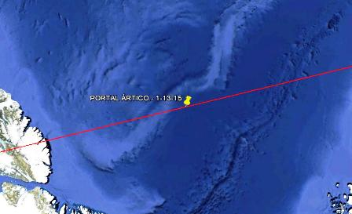
AOther than the Geographical and translation, there are other poles: the magnetic, the geomagnetic, the inaccessibility and the North celestial pole.
This place continually changes over time at a variable speed of 40 km/year and is subject to the investments of the terrestrial magnetic field.
But we enter into their fascinating riddles, as the possible existence of an inner world or "Hollow Earth". Theory on which there is a lot of LiteratuRA, in favor and against.
AUnque, Just for being part of the First tonillo and his Presuntor link to WithInterstellar uniqueness, we already find it valid to believe in the possible ExistsOf The Hollow Earth And it's not a crazy idea, when we see the earth, as a kind of atom, with its central nucleus of protons and neutrons and its electron rings, so far everything seems unreasonable, but when it's in the game Quantum mechanicsAll It begins to take shape, because we must not forget that we are a multidimensional product, and in fact, we only move in 3d, but in reality, only our known universe is 9D.
A POsible proof of his existence might be, The North Polar opening, As we see in the Photo taken by a satellite, That government censorship could not hide. ¿A possible access To the Hollow Earth?
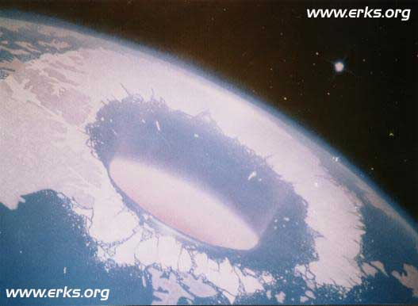
OtrData or Tests Important, It The fact is encuentren Tropical seeds, plants and trees, Floating in fresh waters inside the icebergs. Curiously, thousands of birds and tropical animals emigrate to the North in winter, It is clear that It's hotter at the poles, than 1500 miles from them.
In addition, as it happens in All The telluric points of cosmic communication, it is forbidden to fly above them, the commercial aviation routes They are forbidden to pass near Them.
Antarctica, Like Antarctica, this Analyst, he thinks they are telluric points of first order, the intuition tells me, that his degree of inclination is the work of a programming, of the cosmos, able to move mechanically, through the rings that we will study, so that the creators can "adjust", to the tenth Of milli meter the degree of inclination of the planet, as supreme work of "intelligent design".
What's more, the current inclination perfectly meets the requirements of "private property" for the "entrances and exits" of access to the hollow land, where they surely "reside" when they visit us.

of Antarctica, following the route, we entered Canada, finding in The alignment to Quebec and Ottawa, Its capital. A Your right Is New York and directly About alignment Is Washington D. C. In A kind of homage To timelessness, includingOars in the Rings, ciudades of our present day, as their Position on the planet is no coincidence, Rather Seem Deliberates, Allegedly by their Influences in power and the world economy.

1.11.- NUEVA YORK (40° 40′ 12″ N, 73° 56′ 24″ W)
Distance from 1.10: 5.450 km; Measurement to Origin: 33.890 km

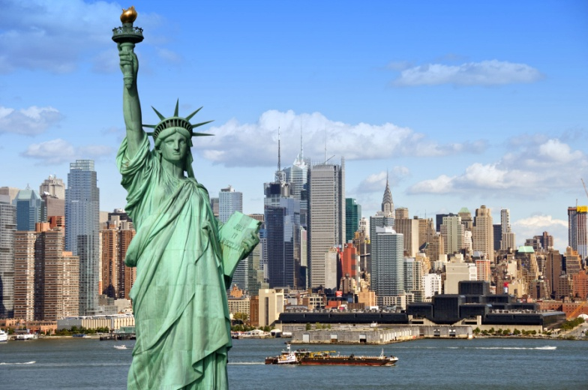
Nueva York1 (In English and officially, New York City) is the most populous city Of The United States of America, and the second largest urban concentration of Continent, just behind the Mexico Federal District.
The center of the New York metropolitan Area It, One of the 5 Largest urban agglomerations in the world.
Since the late nineteenth century is one of the world's leading centers of Commerce and Finance of the planet.
New York is considered a Global City, for its World-wide influences on Mass media, Policy, Education And Entertainment, aOther fashion. Su Influence Artistic and cultural is the Largest of the EE. UU. In this city you will find the Headquarters of the United Nations Organization, which also makes it an important point in international relations.

1.12.- WASHINGTON (38° 53′ 42″, N, 77° 2′ 12″ W )
Distance from 1.11: 250 km.; Measurement at Source: 34.140 km.
Washington D. C., officially called, District of Columbia, It's the capital Of EE. UU.
This is a different entity At 50 States That make up that nation, depends directly on the Federal Government of the United States. The district of Columbia was founded on 16 July Of 1790In 1791 was official within the district, a new city, Washington.
In 1871, the governments of these two cities and the rest of the district's populations were unified in a single entity, D.C.
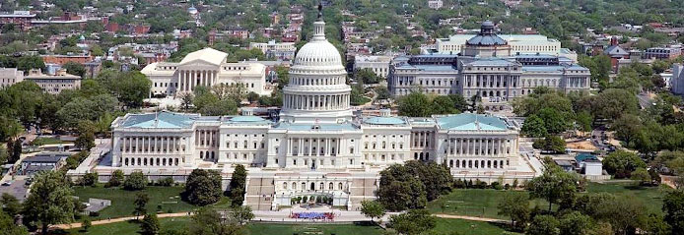

The city of Washington was born as a Planned City, and was developed at the end of the Eighteenth century To serve as the permanent national capital, after several localities held that position, after the Independence of the country, in 1776.
The centers of the three branches of the Government of EE. UU, are located in the district, tAlso the headquarters of the World Bank, Imf, OEA, BIDand other national and international institutions.
It's a real center of power, you really think it's a coincidence that it's in the alignment of the first ring?

Leaving Washington, we are left to the right North Carolina and South Carline, and somewhat later, Georgia y Florida, all the way to the Bahamas. But on the left we left Bermudas And Of A stop, to take a look at the famous TBermuda Riángulo.

1.13.- TRIÁNGULO DE LAS BERMUDAS (25° 0′ 0″ N, 71° 0′ 0″ W)
Distance from 1.12:1.310 km; Measurement To Origin: 35,450 km.

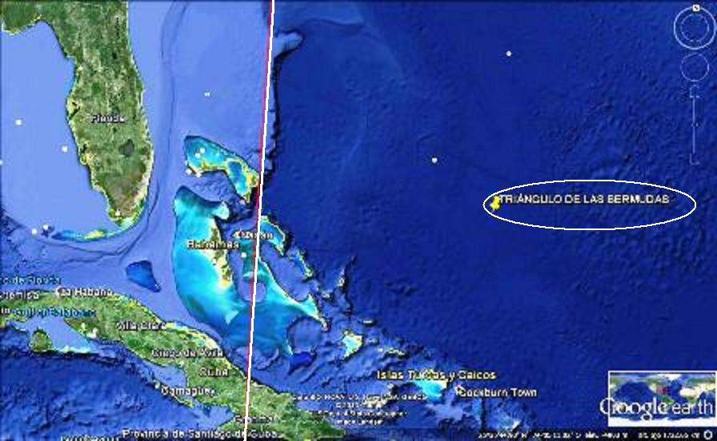
The Bermuda Triangle It is a geographical area, between 1,600 to 1,800 km of side, located in the Atlantic Ocean Between the Bermuda Islands, Puerto Rico and the City of Miami In the Florida. (EE. UU).
Its fame is well known about Disappearances, In their area, of some boats, airplanes and small boats, of WayMysterious. "
This Fame was increased after the decade of the 60, and in a special way, After The publication in 1974 of the book, The Bermuda Triangle, Of Charles Berlitz, who popularized the preSummary Mystery Until Convertedrlo In a myth, in fact, the book is a Combination of Science fiction and research, In any case, the mystery, is no longer intriguing.
The latest news Is, the presumed discovery of a large submerged city, with Pyramids Including, of indefinite dating and that some researchers consider possible remains of ancient Atlantis.
I include this point Telluric, More for their Esoterics enigmas What By Scientific Rigor, In fact, any of the rings are quite far away from the area, so, with all the reservations, I try The area of "novelistic", and if I have to lean over some esoteric point, I am more tangible, leaning towards the enigma of, CORAL CASTLE, In the Bahamas, we'll see in The 4th and 6th Ring Planetary.

From the Bahamas we passed between Cuba and the Dominican Republic, arriving in Jamaica, where the ring, practically crosses Kingston, its capital, entering the Caribbean Sea, until you reach Colombia, where we'll be in the stones of Tunja.

1.14.- PIEDRAS DE TUNJA (4° 48′ 59.59″ N, 74° 20′ 45.59″ W)
Distancia desde 1.13: 2.440 km; Medición a origen: 37.890 km.
El Parque Arqueológico de Facatativá también llamado Piedras del Tunjo erróneamente llamado Piedras de Tunja, Cercado de los Zipas, es un conjunto de pictogramas cuyo origen exacto
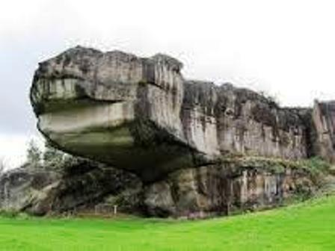
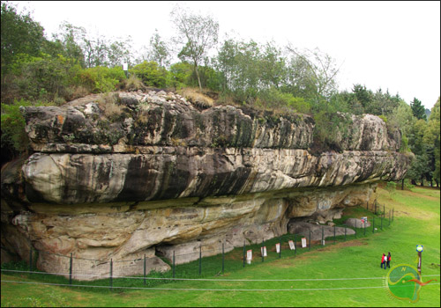

The Facatativá Archaeological Park, Also called Tunjo StonesThe Erroneously Tunja Stones. C, cArket Trends of the Zippy, is a set of Pictograms, Whose exact origin Is Unknown. The Villagers Muiscas informed the chroniclers that they had been made "many moons ago", sOr antiquity has not been determined, but could date from approximately 12 000 years, located in the municipality of Facatativa, in the Department of Cundinamarca, Colombia; It is constituted in the only archaeological park located within the urban area of a municipality.
is curious, The shape of the Picture on the right, Half Dragon, Half "Tank", as a combination of biology and mechanics.

1.15.- VOLCÁN TUNGURAHUA (28′ 1″ S, 78° 26′ 30″ W)
Distancia desde 1.14: 750 km.; Medición a origen: 38.640 km
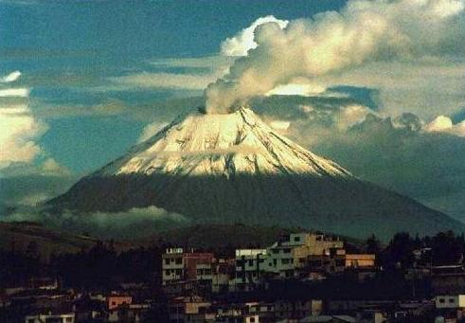
OTra Curiosity, is the volcano Tungurahua, It's a Stratovolcano Active, Located in the Andean Zone Of Ecuador. AndYou are inolcán is in Cordillera Oriental, Boundary of the provinces of Chimborazo and Tungurahua, which gives it its name.
The volcano is Very active, especially from the start of the Third Millennium, the Last Eruption of the volcano, started at 1999 and Sigue Active Until today, With episodes very Violent on July 14, 2006, 16 August 2006, 28 May 2008, 26 April 2010, 20 August 2012, and the plus REciente on February 1, 2014.
Its proximity to the cave of the TayosAthat of The Points Tellurics More Enigmatic of the last times, which we shall see below.
The continuous Eruptions Of The last few Years Make me consider this volcano, As a telluric point Important part of the First ring.

1.16.- CUEVA TAYOS – ECUADOR (3° 3'58.34"S, 78°12'5.43"O)
Distance from 1.15: 190 km.; Measurement at Source: 38.830 km.
The Cave of the Tayos is located in the Republic of Ecuador, in the province of Morona Santiago In a mountainous area called, The Cordillera del Cóndor.
The researcher, nationalized Argentine, Juan MoriczHe said he found Indications of The existence of a very ancient civilization.

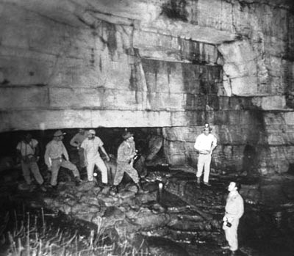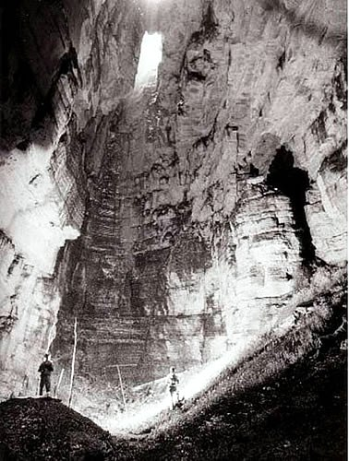

The Salesian priest, Carlo Crespi CrossesWith The cave, when a documentary was made on the Shuar Jibaro in 1927, which bequeathed to him a series of archaeological pieces, foundAllegedly In the Inside the cave, And that the priest kept them in his private museum, In Cuenca (Ecuador).
John's Investigations Moricz Upon these objects he was served as proof to justify the existence of an ancient Hungarian-root culture, Similar to (Hungarian).
The claims of Moricz Were more notorious than those of Carlo Crespi, being popularized by the writer Erich Of Daniken, In his work of 1973, The Gold of the Gods.
Between objects, There are replicas of plates, stelae and figures with Objects from Asian, Mesopotamian, Egyptian cultures, etc.
Most are plates or sheets metallicAs, others are carved stones, RÉplicas oruStems, as is happening with the Ica stones?
All these archaeological vestiges, presumably, Are the summary of the story of an extinct civilization of which we have not, to date, the slightest hint.
Currently there are only some photographs and videos, since most of the objects were sold or stolen in the fire of the Church in 1962.
Like the previous ones, if it is part of the ring, We have to consider this telluric point, for its impressive underground "constructions", as well as for the Ooparts of high level, which are their engraved plates or stones, of a level similar to the Lithic Library.
Very Interesting report The report of Walking among Giants, drawn up by Mr. Hernán Yet, based on photographs of the expeditions to the Cave of the Ecuadorian researcher, Manuel Palacios, there seems to be no doubt of the existence of "energies" of giants in that area.

1.17.- CHAVIN DE HUANTAR (9°35'33.99"S, 77°10'42.41"O)
Distance from 1.16: 750 km; Measurement at Source: 39.580 km.

Chavín de Huantar It's a Center Archaeological of the province of Huari, Department of Ancash, in Peru, 462 km NE of Lima.
The building has a complex network of interior stone paths and galleries illuminated by beams of light, which penetrate through strategically located conduits.
Inside you can see the Monolithic cast, carved stone of 4.54 m. High in which is represented a divinity anthropomorphic, possibly the most important of the Chavín pantheon.
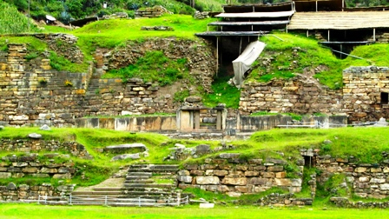

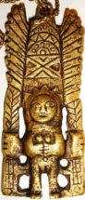
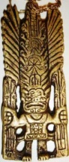
On the walls of the main temple you could see a series of Nail Heads, similar to Those of Tiwanaku, of Bolivia. Sculptural lumps that apparently were the mythological guardians of temples.
The Chavines represented their gods in great Monoliths. The best known are the Monolithic castThe Estela RaimondiThe wake of Yauya and the Tello Obelisk.
Each one of them is a Wanka, which in Quechua Means Power Stone And they have an eminently sacred character.
Some archaeologists interpret that the monolith or Wanka Chavín, It gathers the three elements of the Cosmogonic trilogy of Chavín: Eagle, Snake y Feline, IE (Air, Water y Earth), Deities Repressive who serve as Sentinels and chase away evil. Like this Air, water and land confirm the permanent harmony with the Cosmos, That is transshined throughout the legacy of Chavín.
Conclusions of the Author
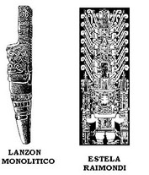
Chavín de HuantarIt One of The Enigmas That fascinate me more than ever, Since one of the most appreciated pieces of my collection is an amulet, That brings together cultures of Chavín de Huantar And Tiwanaku. The obverse Represents to the "Goddess” Of the door of the sun Of Tiwanaku, The Reverse Emulates The Wake Raimondi, of Chavín de Huantar.
This amulet, in addition to its symbolisms, evidently visible And that would require an article of its own, Has properties Unique Out of the ordinary, As it possesses a Reverse process, of "Deoxidation", That generates “Faces” microscópicas Among its furrows, Subjected to a process of mutation "SynchronousZada ", which is changing them", over time.
Ambas faces del amuleto, portan Árboles de Vida en ambas manos, que a priori, representan hebras de ADN, de distintas humanidades, anteriores a la humana. .
The heave is a anthropomorphic figure three times larger than his body to which snakes sprout, to Way to Hair, like some sort of tiara. His right hand is aloft with his fingers extended and the left looks down. This image identified as a feline God (Jaguar) reminds me of other cultures, totally disparate, as The Baphomet of the Templars or the Pazuzu Of The Sumerian, Assyrian, and Acadia mythologies.
According to the writer Eric Of Dániken, in his book: The strategy of the Gods, Chavín de
Huantar, could be the Andean Temple of King Solomon.

1.18.- REGRESO AL CANDELABRO (13°47'38.84"S, 76°18'31.23"O)
Distance to 1.17: 440 km; Measurement at Source: 40.020 km.

The end of the first ring, after passing through VortexS of energy from incredible archaeological sites, is the axis of the Candlestick, curiously, before entering the peninsula, "crosses" an islet of 2.5 km. diámetro. IDéntico to which We have already located in the second part of Nazca, and Call: "Balance Point", It appears to be The point of support Of the lever, which seemed to look Archimedes, to "Move" the world! As eXplico at, Decoded from Nazca, part 2, A TheTéntico advance of the first planetary ring.

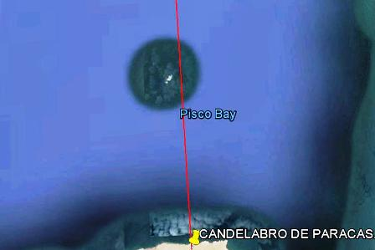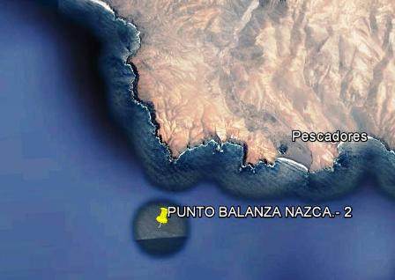

A Of the topics that call the attention of these islets is the fact that, by applying the history of Google Earth, it turns out that a few years ago they have "emerged", presumably, from the bottom of the oceans, we could almost treat them as "artificial".
EN The following articles of Rings, we will see that it is not the hand of man, which is present in the precision of location of these telluric points and that have precise functions for the communication between the cosmos and the planet, including the humanities that inhabit it.

Summary

Introduction 1
First ring 2
1.1.-PARACAS Candlestick (13 ° 47 ' 38.84 "S, 76 ° 18 ' 31.23" O) 3
1.2.-Antarctica (89 ° 26 ' 35.27 ' S, 140 ° 51 ' 25.15 ' E) 4
1.3.-Pirámide Mountain Meadows (6 ° 59 ' 35.77 "S, 107 ° 3 ' 22.92" E) 5
1.4.-Temples of ANGKOR (13 ° 26 ' 12.92 "N; 103 ° 52 ' 38.02" E) 5
1.5.-Plain of the jars (19 ° 26 ' 0.86 "N,103 ° 9 ' 8.14" E) 6
Great Buddha LESHAN (29 ° 32 ' 42.43 "N, 103 ° 46 ' 35.04" E) 6
1.7.-MAIJISHAN Caves (34 ° 23 ' 25.88 ' N, 106 ° 6 ' 51.00 ' E) 7
1.8.-Pyramids of XI'AN (34 ° 21 ' 43.45 "N, 108 ° 38 ' 30.52" E) 8
1.9.-Lake BAIKAL.-1 (52 ° 7 ' 43.29 ' N, 105 ° 46 ' 14.38 ' E) 9
1.10.-Arctic PORTAL (90 ° 0 ′ 0 ″ N, 0 ° 0 ′ 0 ″ e) 10
1.11.- NUEVA YORK (40 ° 40 ′ 12 ″ N, 73 ° 56 ′ 24 ″ W) 11
1.12.- WASHINGTON (38 ° 53 ′ 42 ″, N, 77 ° 2 ′ 12 ″ W) 11
1.13.-Bermuda Triangle (25 ° 0 ′ 0 ″ N, 71 ° 0 ′ 0 ″ W) 12
1.14.-TUNJA Stones (4 ° 48 ′ 59.59 ″ N, 74 ° 20 ′ 45.59 ″ W) 12
1.15.-TUNGURAHUA Volcano (28 ′ 1 ″ S, 78 ° 26 ′ 30 ″ W) 13
1.16.-CUEVA TAYOS – ECUADOR (3 ° 3 ' 58.34 's, 78 ° 12 ' 5.43 ' O) 13
1.17.-CHAVIN DE HUANTAR (9 ° 35 ' 33.99 "S, 77 ° 10 ' 42.41" O) 14
1.18.-Return to the chandelier (13 ° 47 ' 38.84 "S, 76 ° 18 ' 31.23" O) 15
Summary 16

